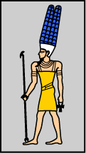 | Name | Amun
 | Gender | Male
 | Role | King of the Gods
 | Head | Ram

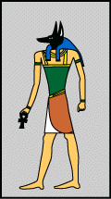 | Name | Anubis
 | Gender | Male
 | Role | God of embalming
 | Head | Jackal

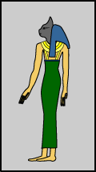 | Name | Bastet
 | Gender | Female
 | Role | Goddess of protection
 | Head | Cat

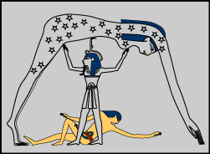 | Name | Geb
 | Gender | Male
 | Role | God of the earth
 | Head | Goose

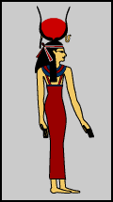 | Name | Hathor
 | Gender | Female
 | Role | Goddess of love and joy
 | Head | Cow ears

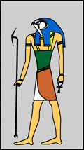 | Name | Horus
 | Gender | Male
 | Role | God of the sky
 | Head | Hawk

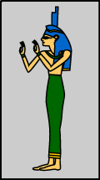 | Name | Isis
 | Gender | Female
 | Role | Goddess of love, fertility and healing
 | Head | Cow horns

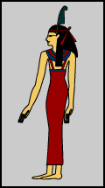 | Name | Ma’at
 | Gender | Female
 | Role | Goddess of truth, justice and harmony
 | Head | Feather on her head

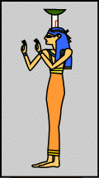 | Name | Nephthys
 | Gender | Female
 | Role | Goddess of protecting the dead
 | Head | Wearing a headdress

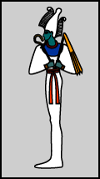 | Name | Osiris
 | Gender | Male
 | Role | God of the dead
 | Head | Wearing a cone with feathers

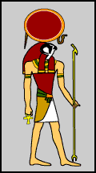 | Name | Ra
 | Gender | Male
 | Role | God of the sun
 | Head | Hawk

